**Assignment 1**

Create table1 as worker with their ID,first name ,last name ,salary,joining date ,department & table 2 Bonus with workers ref ID, Bonus date ,Bonus amount and table 3 Title with worker ref ID ,worker title.fill the details in each row of tables by making use of DDL & DML commands.

Create database factory;

Use factory;

create table worker(id int not null primary key,

firstName varchar(20) not null,

lastName varchar(20) not null,

salary int, joiningDate date,

department varchar(20));

desc worker;

create table bonus(refId int not null,

bonusDate date,

bonusAmount int,

foreign key (refId) references worker(id));

desc bonus;

create table title(refId int not null,

workerTitle varchar(20) not null,

foreign key (refId) references worker(id));

desc title;

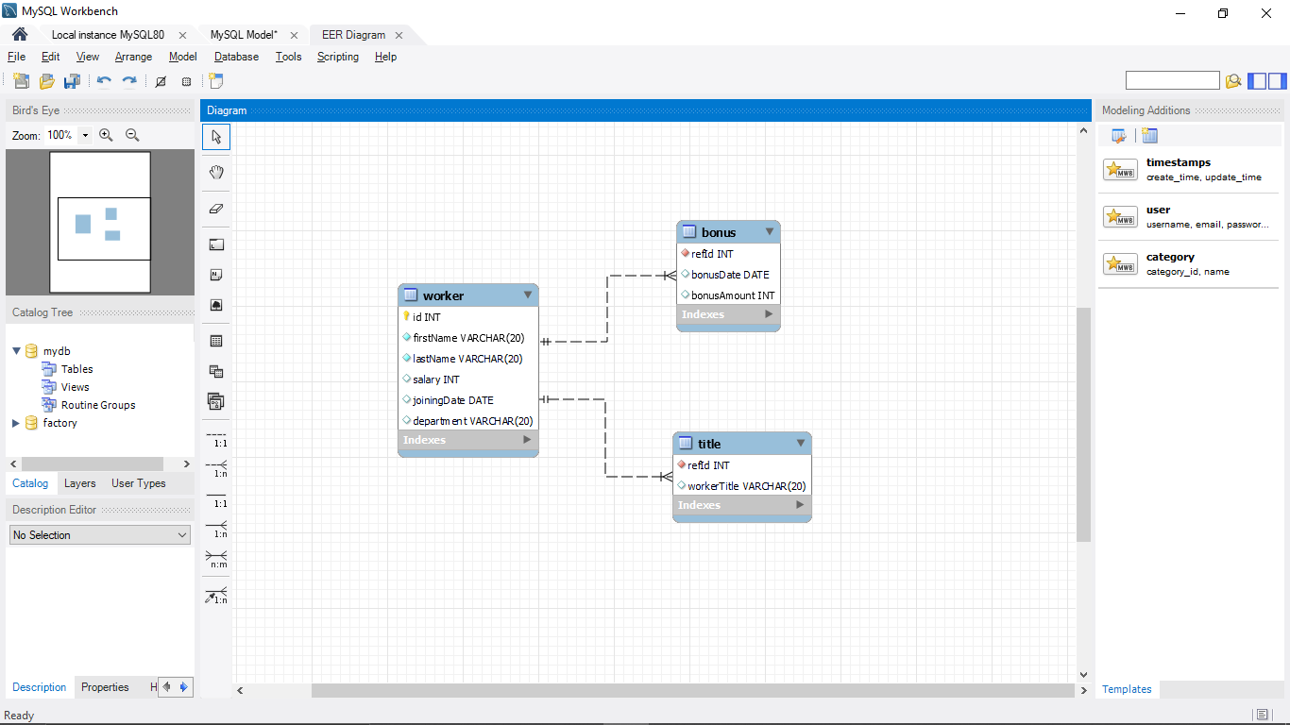

insert into worker values(1, "jeethendra", "S R", 100000, "2022-08-17", "CSE");

insert into worker values(2, "Monika", "B A", 100000, "2022-08-9", "CSE");

insert into worker values(3, "Shivkumar", "Panchal", 100000, "2022-08-20", "IT");

select * from worker;

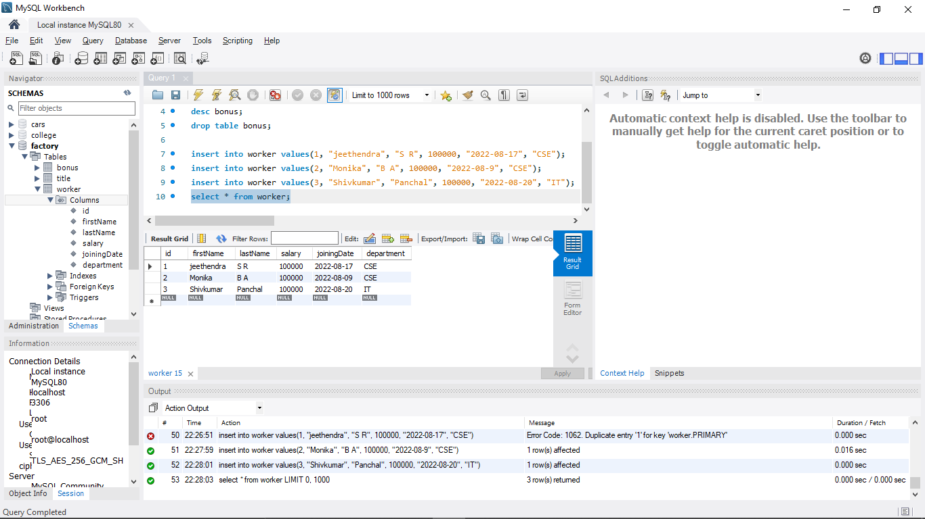

insert into title values(1, "Software Engineer");

insert into title values(2, "SDE-1");

insert into title values(3, "Software Engineer-2");

select * from title;

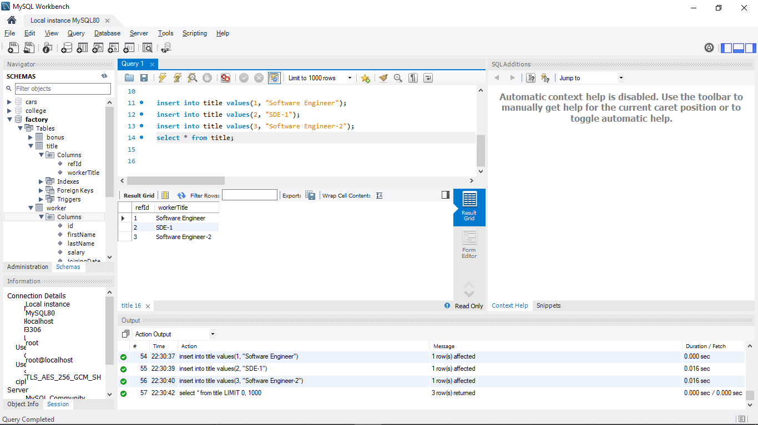

insert into bonus values(1, "2022-09-17", 30000);

insert into bonus values(3, "2022-09-17", 70000);

select * from bonus;

